**Week 5 -Microservices with Spring Boot 3 and Spring Cloud**

**Microservices with API gateway**

**Creating Microservices for account and loan**

**AccountController.java**

package com.cognizant.account.controller;

import org.springframework.web.bind.annotation.*;

import java.util.*;

@RestController

@RequestMapping("/accounts")

public class AccountController {

@GetMapping("/{number}")

public Map<String, Object> getAccount(@PathVariable String number) {

Map<String, Object> response = new HashMap<>();

response.put("number", number);

response.put("type", "savings");

response.put("balance", 234343);

return response;

}

**LoanController.java**

package com.cognizant.loan.controller;

import org.springframework.web.bind.annotation.*;

import java.util.*;

@RestController

@RequestMapping("/loans")

public class LoanController {

@GetMapping("/{number}")

public Map<String, Object> getLoan(@PathVariable String number) {

Map<String, Object> response = new HashMap<>();

response.put("number", number);

response.put("type", "car");

response.put("loan", 400000);

response.put("emi", 3258);

response.put("tenure", 18);

return response;

}

}

}

**application.properties**

server.port=8081

<http://localhost:8081/loans/H00987987972342>

**OUTPUT**

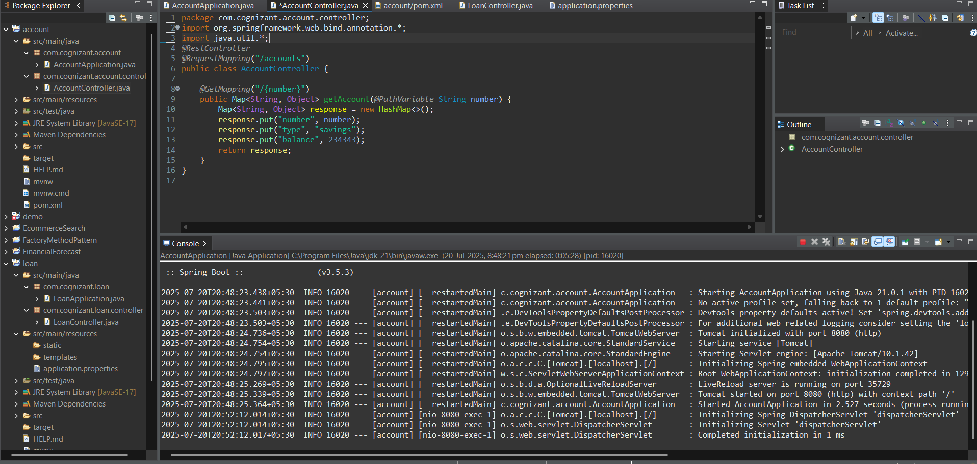

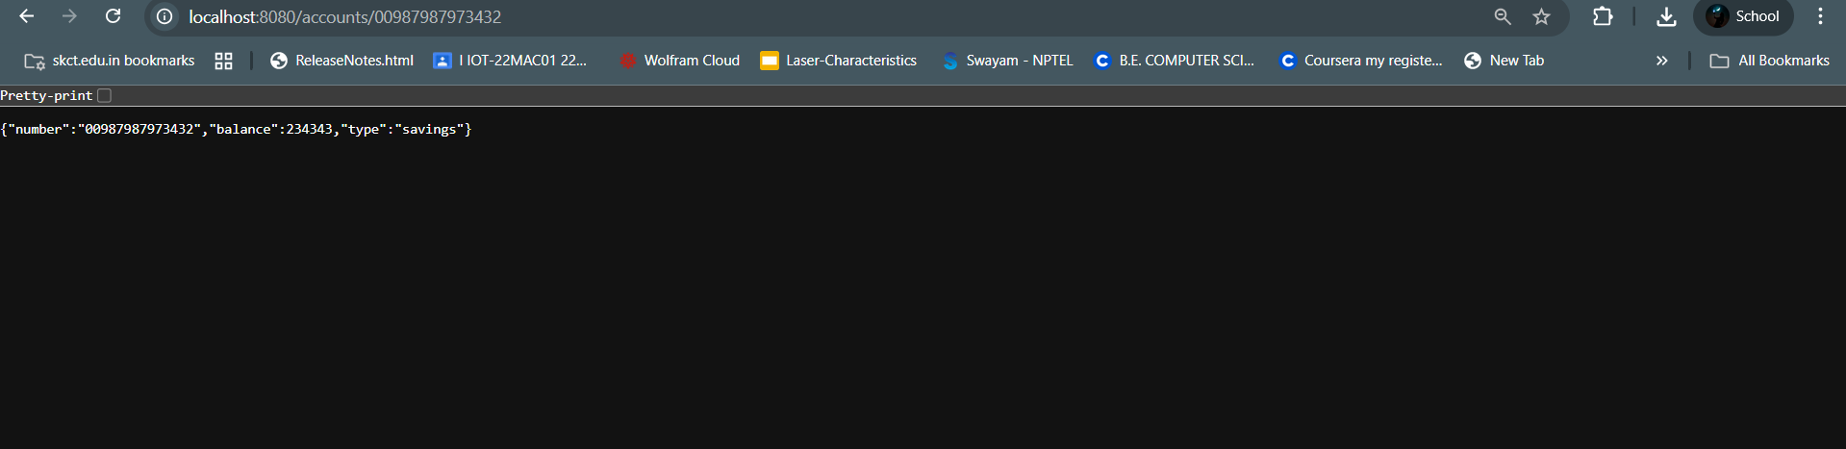

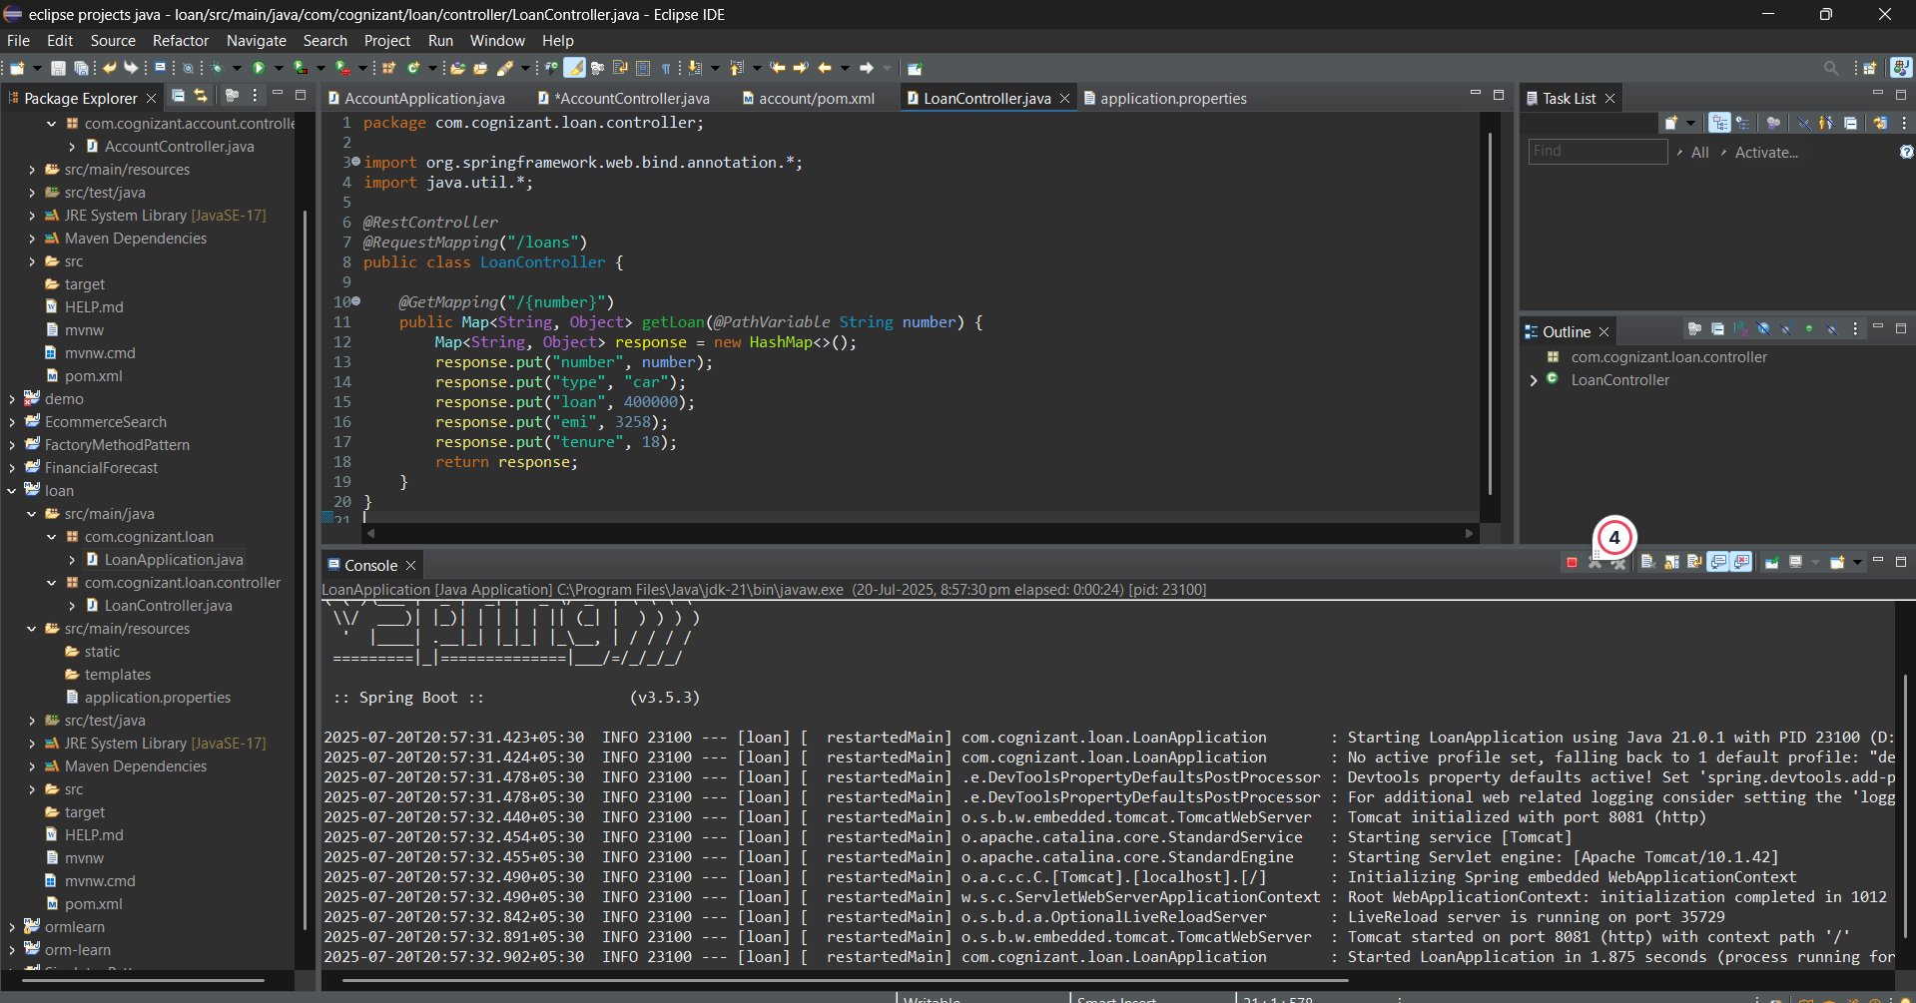

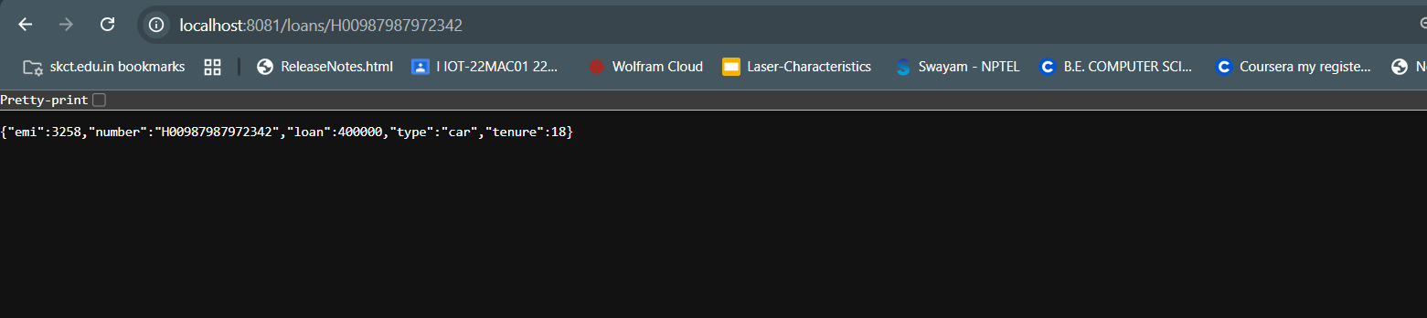

**Create Eureka Discovery Server and register**

**pom.xml**

<parent>

<groupId>org.springframework.boot</groupId>

<artifactId>spring-boot-starter-parent</artifactId>

<version>3.3.1</version>

</parent>

<dependencies>

<dependency>

<groupId>org.springframework.cloud</groupId>

<artifactId>spring-cloud-starter-netflix-eureka-server</artifactId>

</dependency>

</dependencies>

<dependencyManagement>

<dependencies>

<dependency>

<groupId>org.springframework.cloud</groupId>

<artifactId>spring-cloud-dependencies</artifactId>

<version>2023.0.1</version>

<type>pom</type>

<scope>import</scope>

</dependency>

</dependencies>

</dependencyManagement>

**EurekaDiscoveryServerApplication.java**

package com.example.eurekaserver;

import org.springframework.boot.SpringApplication;

import org.springframework.boot.autoconfigure.SpringBootApplication;

import org.springframework.cloud.netflix.eureka.server.EnableEurekaServer;

@SpringBootApplication

@EnableEurekaServer

public class EurekaDiscoveryServerApplication {

public static void main(String[] args) {

SpringApplication.run(EurekaDiscoveryServerApplication.class, args);

}

}

**application.properties**

spring.application.name=eureka-discovery-server

server.port=8761

eureka.client.register-with-eureka=false

eureka.client.fetch-registry=false

eureka.client.service-url.defaultZone=http://localhost:8761/eureka

logging.level.com.netflix.eureka=OFF

logging.level.com.netflix.discovery=OFF

Registering a Microservice with Eureka

**pom.xml**

<parent>

<groupId>org.springframework.boot</groupId>

<artifactId>spring-boot-starter-parent</artifactId>

<version>3.3.1</version>

</parent>

<dependencies>

<dependency>

<groupId>org.springframework.boot</groupId>

<artifactId>spring-boot-starter-web</artifactId>

</dependency>

<dependency>

<groupId>org.springframework.cloud</groupId>

<artifactId>spring-cloud-starter-netflix-eureka-client</artifactId>

</dependency>

</dependencies>

<dependencyManagement>

<dependencies>

<dependency>

<groupId>org.springframework.cloud</groupId>

<artifactId>spring-cloud-dependencies</artifactId>

<version>2023.0.1</version>

<type>pom</type>

<scope>import</scope>

</dependency>

</dependencies>

</dependencyManagement>

**AccountServiceApplication.java**

package com.example.accountservice;

import org.springframework.boot.SpringApplication;

import org.springframework.boot.autoconfigure.SpringBootApplication;

import org.springframework.cloud.client.discovery.EnableDiscoveryClient;

@SpringBootApplication

@EnableDiscoveryClient

public class AccountServiceApplication {

public static void main(String[] args) {

SpringApplication.run(AccountServiceApplication.class, args);

}

}

**application.properties**

spring.application.name=account-service

server.port=8081

eureka.client.service-url.defaultZone=http://localhost:8761/eureka

**GreetController.java**

@RestController

@RequestMapping("/greet")

public class GreetController {

@GetMapping

public String greet() {

return "Hello World";

}

}

**LogFilter.java**

@Component

public class LogFilter implements GlobalFilter {

private static final Logger logger = LoggerFactory.getLogger(LogFilter.class);

@Override

public Mono<Void> filter(ServerWebExchange exchange, GatewayFilterChain chain) {

logger.info("Incoming request: {}", exchange.getRequest().getURI());

return chain.filter(exchange);

}

}

**OUTPUT:**

